Experiment 1.3
Variable Transformation between Cartesian, Cylindrical, and Spherical coordinate systems

Code File Name: Exp1_3_Sph2CartCyl.m
Code
clc;
r=input('Enter the value of r=');
phi=input('Enter the value of phi=');
theta=input('Enter the value of theta=');
% Spherical to Cartesian
x=r*sind(theta)*cosd(phi);
y=r*sind(theta)*sind(phi);
z=r*cosd(theta);
disp('spherical to cartesian coordinate system of p(x,y,z)=');
disp([x y z]);
% Spherical to Cylindrical
rho=r*sind(theta);
disp('spherical to cylindrical coordinate system of s(rho,phi,z)=');
disp([rho phi z]);
Command Prompt
Enter the value of r=10
Enter the value of phi=15
Enter the value of theta=20
spherical to cartesian coordinate system of p(x,y,z)=
3.3037 0.8852 9.3969
spherical to cylindrical coordinate system of s(rho,phi,z)=
3.4202 15.0000 9.3969
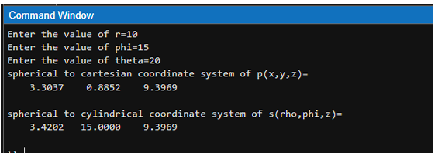
Output Graph / Screenshot

